Mohamed Ahmed Mohamed Abd-Elgani
===============================
1. Compress a file by compress, gzip, zip commands and decompress it again. State the
differences between compress and gzip commands.
Compress
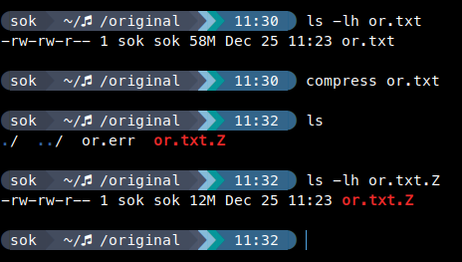

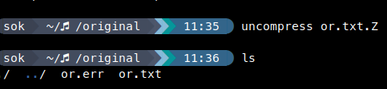

gzip
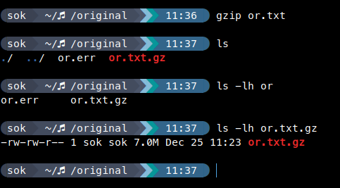

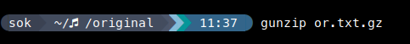

zip
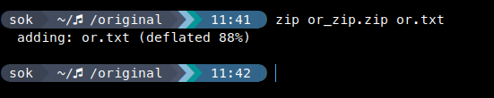

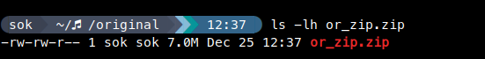

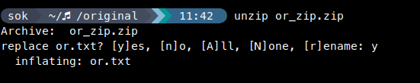

 | Compress | Gzip | Zip
size | 12 | 7 | 7
Result ex | .z | .gz | .zip
Replace Source file | Yes | yes | no

2.What is the command used to view the content of a compressed file.
Zcat ==> zip – gzip

bzcat ===> bzip

3.Backup /etc directory using tar utility.

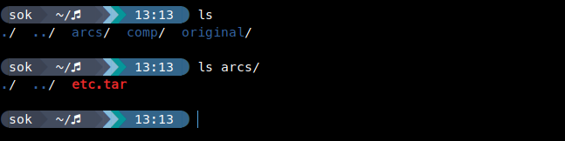

4. Starting from your home directory, find all files that were modified in the last two day.

5. Starting from /etc, find files owned by root user.

6. Find all directories in your home directory.
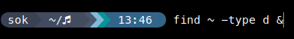

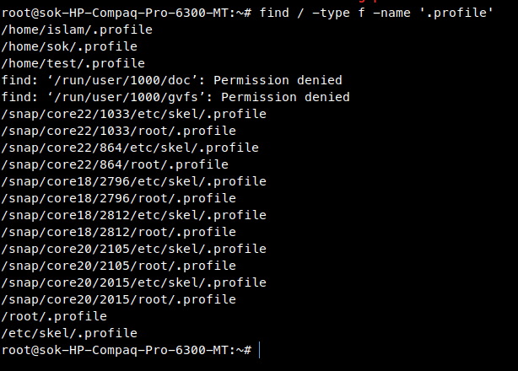
7.Write a command to search for all files on the system that, its name is “.profile”.
8.Identify the file types of the following: /etc/passwd, /dev/pts/0, /etc, /dev/sda

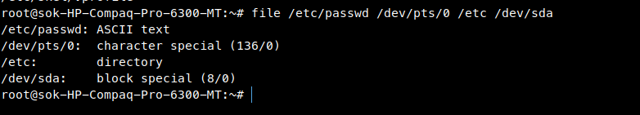
9. List the inode numbers of /, /etc, /etc/hosts.

10. Copy /etc/passwd to your home directory, use the commands diff and cmp, and Edit in the
file you copied, and then use these commands again, and check the output.

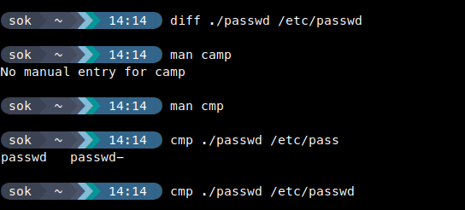

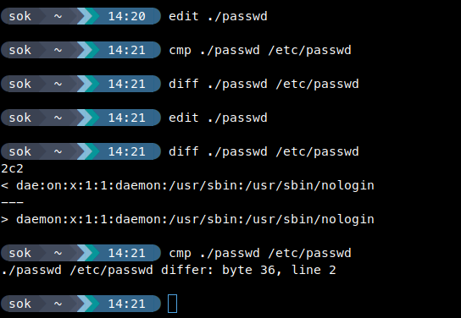

11. Create a symbolic link of /etc/passwd in /boot.
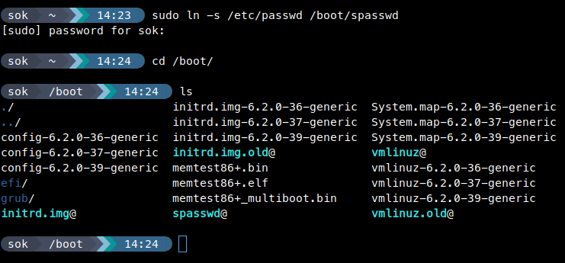
12. Create a hard link of /etc/passwd in /boot. Could you? Why?

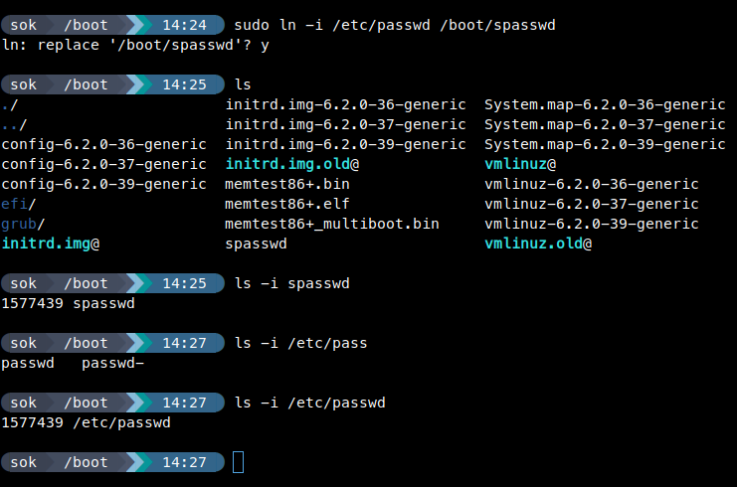
Self study
dpkg | apt
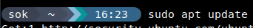

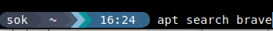

yum | rpm
yum install Brave ==>install  yum update Brave==>update  yum remove Brave==>remove | rpm -ivh Brave.rpm==> install  rpm -Uvh Brave.rpm==>update  rpm -e Brave==>remove

